

Umair Khalid

**Assignment**

**Comsats university Islamabad,Lahore Campus**

***Topic :***

**Console of**

**project**

Submitted by:

Roll no:

SP24-BSE-119

Submitted to

Sir Shahid Bhatti

Date

11 Oct 2024

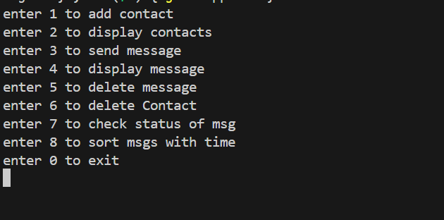

I am entering 1 to add Contact

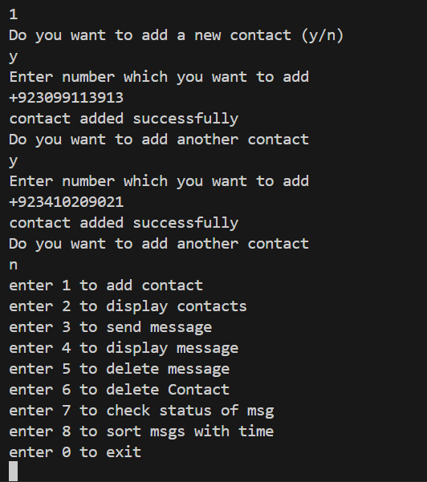

Now I am gonna display all available contacts

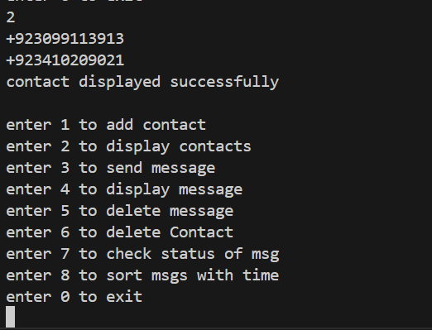

Now I am gonna send message to specific contact e.g.First contact

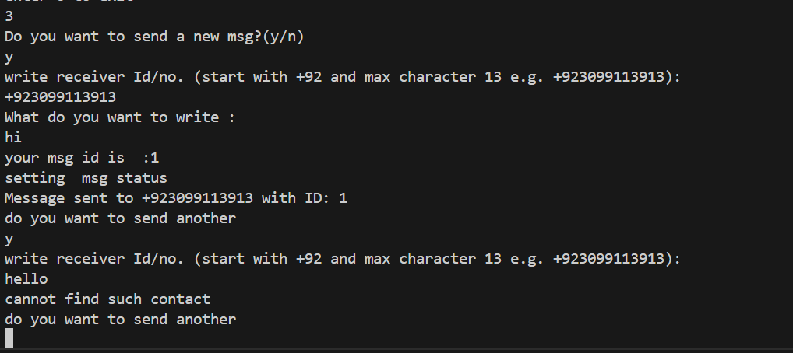

Now I am going to display all available msgs for specific number

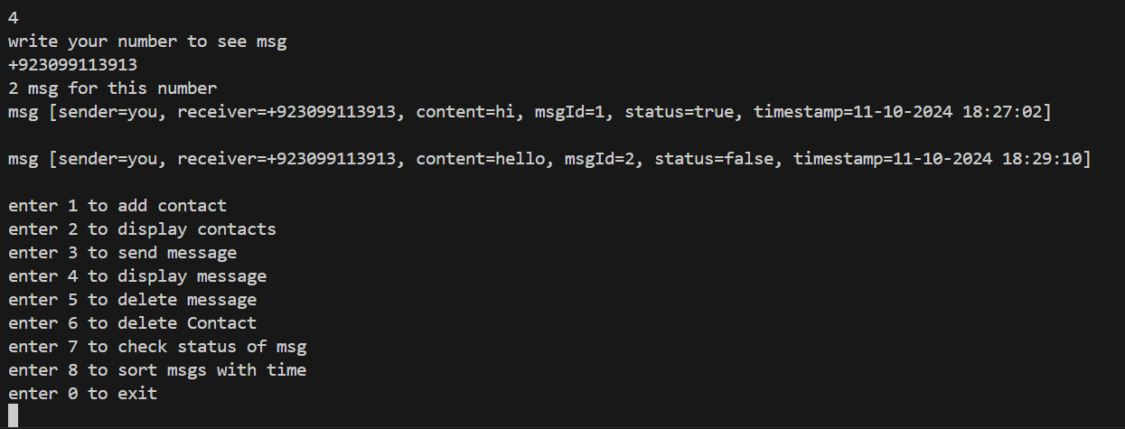

Now I Would dlt message but first I would add send more messages so that there would be no problem while sorting.First it would display all available msgs for that number and then it would take choice from me to select specific msg id to delete it.This function helps deleting specific msg.

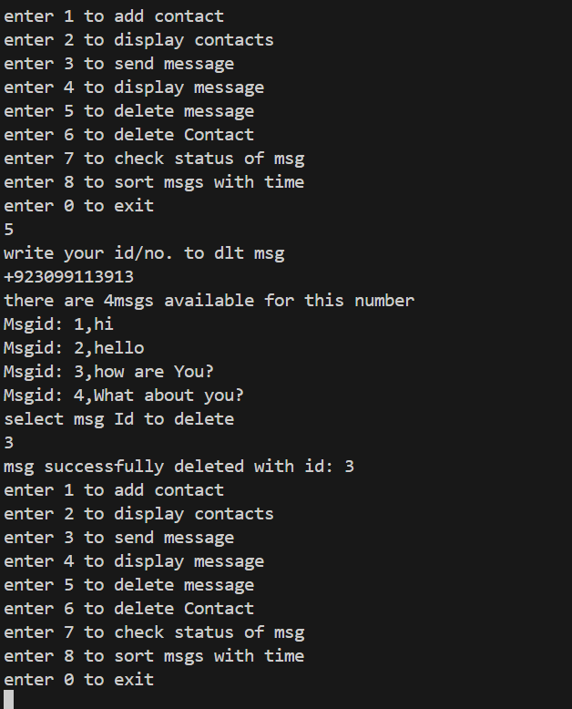

Its time to check the delete contact function.I am going to press 6 to delete contact.

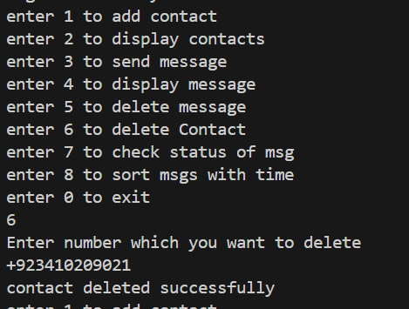

Lets check the msgs are seen or not.I am going to press 7 for this purpose.I have added some new messages but still not displayed them but displayed the earlier ones.Lets see how code sort out this

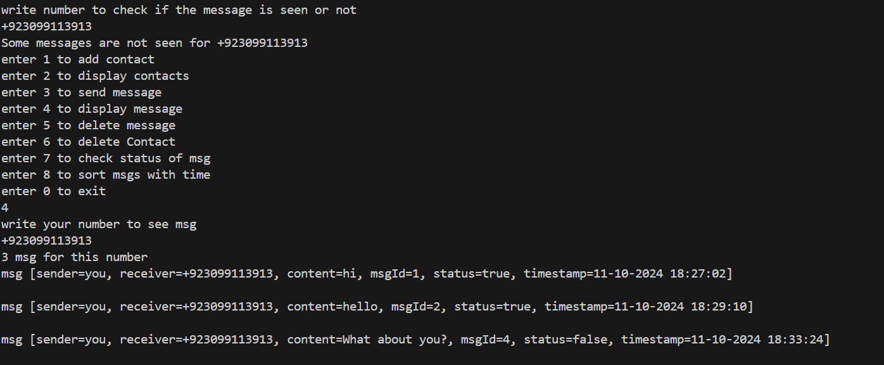

Let me display all messages now

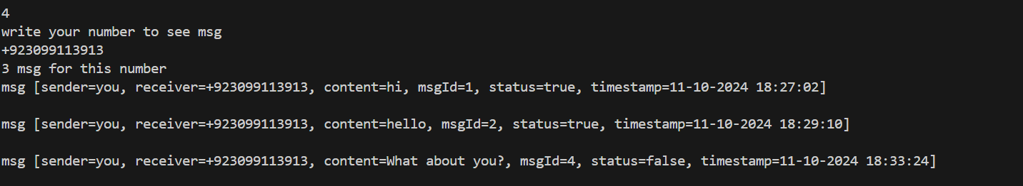

Its time to check status of msgs

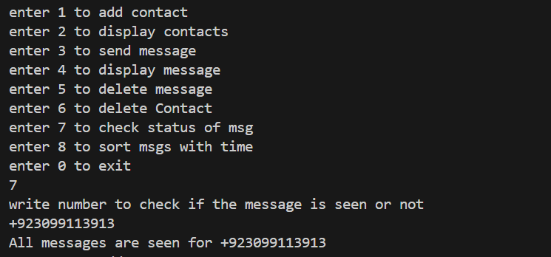

As we have checked almost all functions.So lets check the sort msg function also

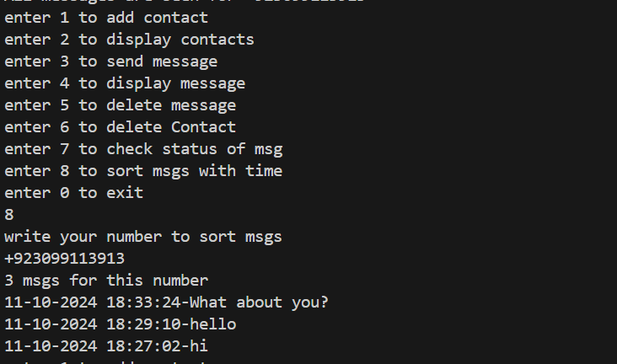

All functions are working fine.Lets press 0 to exit the code

